

Special Educational Needs & Disabilities Information Report
June 2026

Contents

1. Welcome and key information
2. What SEND means at Trinity
3. How we identify SEND
4. How we support pupils
5. The Core Offer
6. SEND interventions and safe spaces.
7. SEND staff and wider support
8. Funding, training and review

9. Transition
10. Access and inclusion
11. Parent, carer and pupil voice
12. Raising concerns
13. Useful links

Document details

Date issued | June 2026
SEND Governor | Mr C. Francis
Nominated Lead Members of Staff | Mrs P. Latimer-Newnham & Mr M. Griffin
Review cycle | Statutory - annually
Next review date | June 2027
Author | Mrs P. Latimer-Newnham

1. Welcome and key information.
This report explains how The Trinity Catholic School supports pupils with Special Educational Needs and Disabilities (SEND).
Our aim is to help every pupil feel included, make progress, and develop the skills they need for school life and beyond.
We follow the Our Lady of Lourdes Multi-Academy Trust SEND Policy. This is available on the school website:
https://www.trinity.nottingham.sch.uk/wp-content/uploads/sites/44/2023/06/OLOL-SEND-POLICY-MARCH-2026.pdf

National figures for 2026 show that 14.8% of pupils receive SEN Support and 6.0% have an EHC plan. Trinity reviews its own SEND information regularly.
https://explore-education-statistics.service.gov.uk/find-statistics/special-educational-needs-in-england/2025-26

SEND Status | Number | % of roll at Trinity
Pupils with an EHC plan (EHCP) | 7 | 0.59%
Pupils identified as SEN Support (K) | 85 | 7.22%
Pupils on the SEND register (EHCP and K) | 92 | 7.81%
Pupils monitored for SEND (M) | 95 | 8.06%

*The SEND register is active. This means which pupils are on the SEND register will change according to need.
**Current school roll: 1178 pupils. SEND information is correct at the time of publication 22.06.2026.

2. What SEND means at Trinity.
SEND can affect different areas of learning and school life. Some pupils have needs in more than one area.
- Moderate Learning Difficulties
- Specific Learning Difficulties, e.g. Dyslexia, Dyscalculia & Dyspraxia (DCD)

Cognition & Learning

Communication & Interaction

- Autism Spectrum Disorder (ASD)
- Speech, Language & Communication Needs

- Hearing Impairment
- Physical Disability
- Visual Impairment

Physical & Sensory Needs

- Attention Deficit Hyperactivity Disorder (ADHD)
- Attention Deficit Disorder (ADD)
- Tourette’s Syndrome
- Anxiety

Social, Emotional & Mental Health

Pupils can have more than one diagnosis or area of need.
Useful video clips.





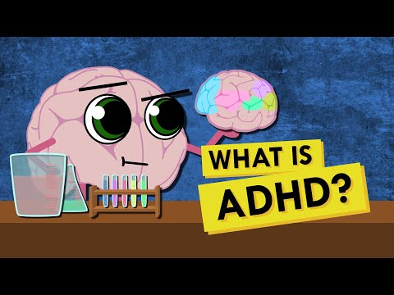


3. How we identify SEND
We use a range of information to understand each pupil’s strengths and needs. This helps us decide what support may be helpful.
- information from primary schools or previous schools
- CAT4 tests and school assessment data
- teacher observations and feedback
- parent/carer concerns
- pupil voice
- external professional advice, where available

Slow progress or low attainment does not always mean a pupil has SEND. We look carefully at the full picture before making decisions.
When pupils access support, we use an Assess, Plan, Do, Review cycle. Pupils on the SEND register have a review each term, with a member of the SEND department.
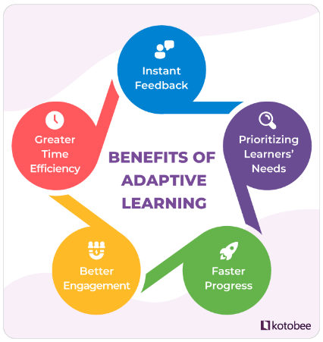
4. How we support pupils
High-quality teaching in the classroom is the first step (Quality-First Teaching QFT). Teachers adapt lessons so that pupils can access learning and make progress.
When it is appropriate, support may include:
- adapted resources or tasks
- extra processing time or instructions broken into steps
- key vocabulary taught before a lesson
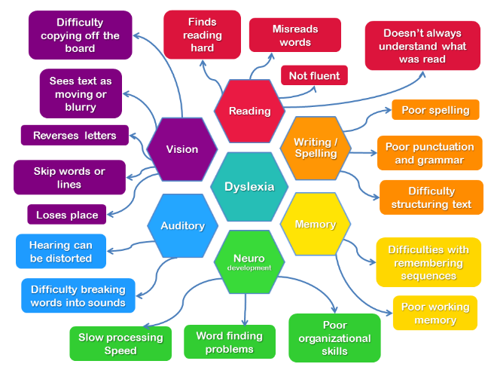
- laptops, overlays, visual timetables, larger font or clear fonts
- read-aloud or voice-recognition tools
- noise-reducing earbuds, where agreed
- passes to support sensory or emotional needs
- small-group or one-to-one intervention, where appropriate
5. The Core Offer
The Core Offer is the support that teachers can use in lessons for pupils with SEND. It sets out reasonable adjustments that can help pupils take part, understand learning and show what they know.
The SENDCo also shares extra advice and resources with staff when a pupil has a more specific need.
https://www.trinity.nottingham.sch.uk/information/send/
The Core Offers are available in the SEND section of the school website.

6. SEND interventions and safe spaces.
The SEND Department can offer a range of interventions, depending on need, staffing, and availability. These may include:
- reading, phonics and Thinking Reading support
- White Rose mathematics or precision teaching
- check-ins, mentoring, or key worker sessions
- Zones of Regulation, 5-point scale or SEMH support
- Life Skills or AIMS Awards for identified pupils
- Lego Therapy, sensory activities or Speech and Language Therapy (SaLT) sessions
- quiet safe spaces at break and lunch times
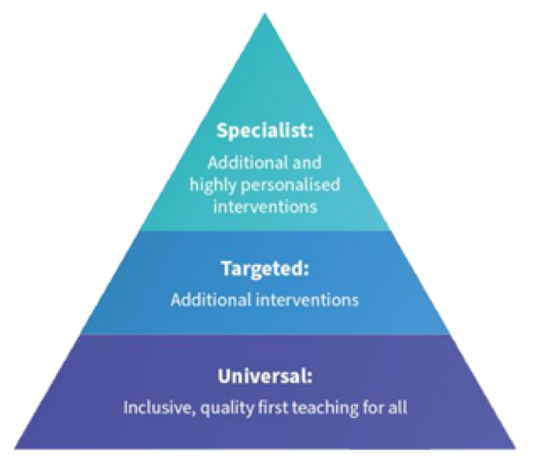
The Emmaus Centre is the main base for the SEND Team. There is also a SEND support room on the Kingsbury site, KS4 support room on the English corridor. Pupils can speak to SEND staff in these areas or arrange to meet staff elsewhere in school.

7. SEND staff and wider support.
The main members of staff linked to SEND are:
- Mrs P. Latimer-Newnham - SENDCo
- Miss R. Crisp - Lead TA / Assistant to the SENDCo
- Mr M. Griffin - Deputy Headteacher and Line Manager for SEND
- Mr M. Shenton - Head Teacher
- Mr C. Francis - SEND Governor

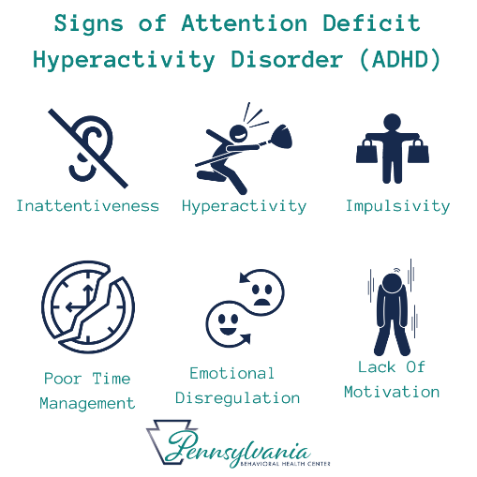
Teaching assistants support pupils where this is identified through pupil profiles, provision maps, EHC plans, HLN funding or other agreed support plans.
We also collaborate with external professionals, such as:
- Speech and Language Therapy (SaLT)
- CAMHS and the Mental Health Support Team (MHST)
- Occupational Therapy (OT) and medical professionals
- Educational Psychology
- Local Authority Autism and Cognition and Learning Teams

8. Funding, training and review
Schools receive SEND funding to help meet pupils’ needs. This funding is not directed to one named pupil. It may be used in different ways, depending on need.
- extra resources or specialist equipment
- small-group support
- specialist programmes
- teaching assistant support
- time for staff to prepare or adapt resources

Where a pupil needs a higher level of support, and parents/carers agree, school may apply to the Local Authority for High Level Needs (HLN) funding.
Staff access SEND training through the Trust, The National College, the Local Authority, health services and external professionals. We review SEND provision during the year through pupil voice, observations, SEND reviews and department evaluation.

9. Transition
We support pupils with SEND when they move into Trinity, move between Key Stages, or choose GCSE and post-16 pathways.
- The Lead TA and Primary Liaison staff gather information from primary schools.
- Some pupils are invited to extra transition sessions.
- Additional visits can be arranged when needed.
- Pupils receive support with options and future pathways through careers lessons, key worker meetings and parents’ evenings.
10. Access and inclusion
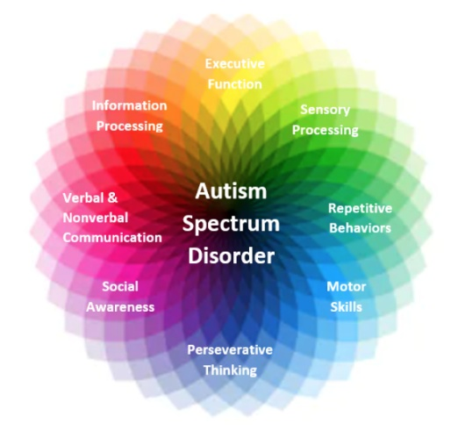
The Trinity Catholic School is a split-site school. Many buildings are from the 1960s and the two main campuses are separated by a main road. This can make access more difficult for some pupils with physical disabilities.
We support pupils individually. Support may include:
- early movement between lessons
- staff support for transitions, where needed
- re-rooming lessons to ground-floor rooms when possible
- risk assessments and evacuation plans
- reasonable adjustments for trips and extra-curricular activities
The SENDCo and Lead TA work with pastoral staff, curriculum staff and trip leaders to consider pupil needs and make suitable adjustments where possible.

11. Parent, carer and pupil voice
Parents, carers and pupils are important partners in SEND support. We want to understand what is working well and what may need to change.
Parents and carers can share views through:
- email or phone contact with teachers, form tutors or the SENDCo
- SEND reviews, usually once each term for pupils on the SEND register
- parents’ evenings, where the SENDCo or Lead TA are available
- the SEND Parent/Carer Comment and Feedback Form on the school website
Pupils can share their views through:
- form time, lessons and verbal feedback
- Pupil Profile meetings and reviews
- talking to the SENDCo, Lead TA, form tutor, Head of Year or key worker
- the pupil voice form on the school website
12. Raising concerns
Please contact us if you have a concern about SEND support. We will try to resolve concerns through discussion and agreed actions.

SENDCo email: p.latimer@trinity.nottingham.sch.uk

SEND inbox: senco@trinity.nottingham.sch.uk

Concerns can also be raised through the form tutor, Head of Year or the SEND Parent/Carer Comment and Feedback Form.

If a concern is not resolved, parents/carers can use the school Complaints Policy. For concerns about admissions or statutory EHC needs assessments, please contact Nottingham City Council (or Nottingham County Council for those with a county post code).

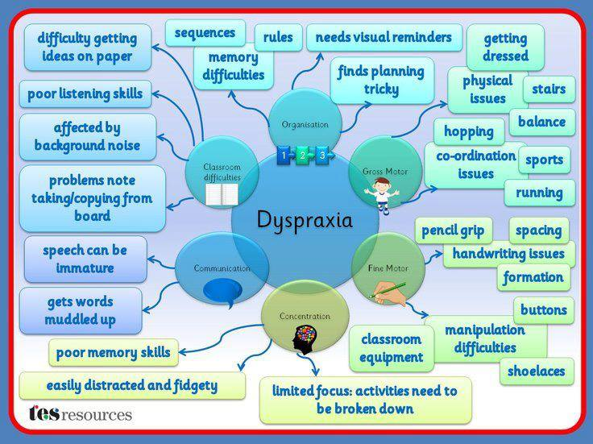

Useful links
Local Offer:
https://www.yournottsdirectory.org.uk/send-local-offer/nottingham-city/nottingham-city-send-local-offer

Special Educational Needs Service:
https://www.nottinghamcity.gov.uk/information-for-residents/education-and-schools/special-educational-needs-service/

Nottingham City EHC Hub:
https://ehchub.nottinghamcity.gov.uk/authgate/

Nottingham County EHC Hub:
https://ehchub.nottinghamshire.gov.uk/authgate/

Health for teens:
https://www.healthforteens.co.uk/?location=Nottinghamshire

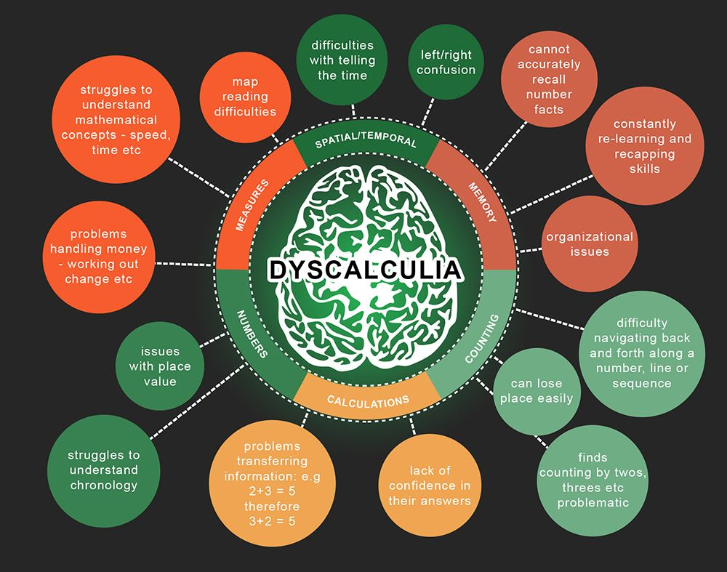
Nasen:
https://nasen.org.uk/

National Autistic Society:
https://www.autism.org.uk/

British Dyslexia Association:
https://www.bdadyslexia.org.uk/

ADHD Foundation:
https://www.adhdfoundation.org.uk/

Please contact the SEND Team if you would like help finding information or understanding SEND support in school.

