Careers Policy

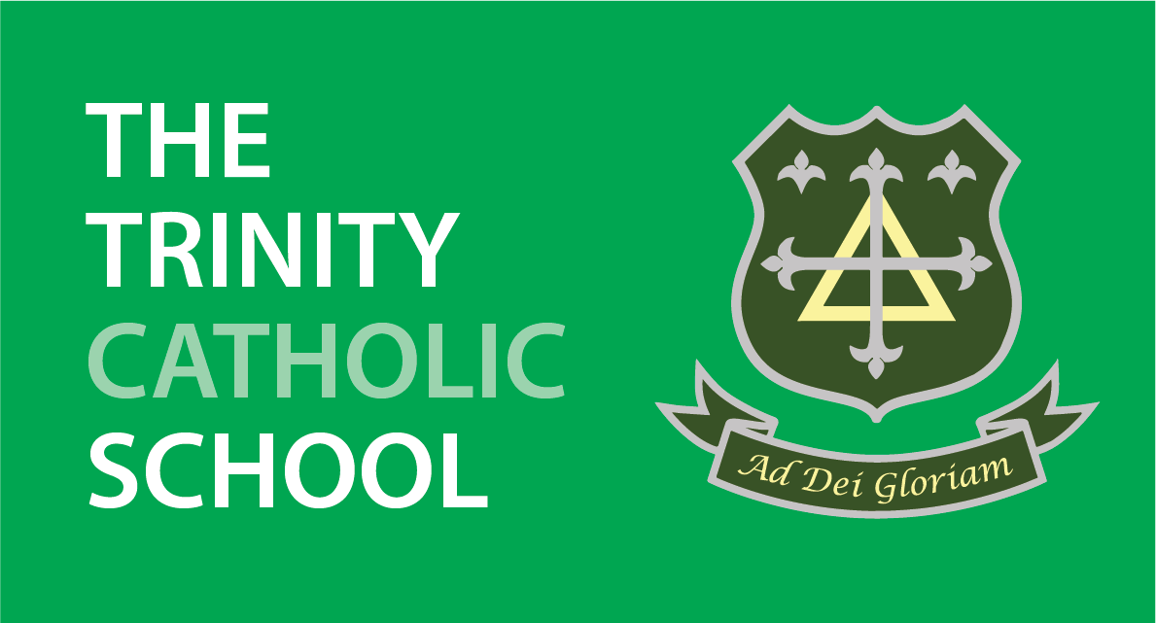
Date Issued | November 2024
Governors’ Committee Responsible: | The Trinity Catholic School FGB  Link Governor: Chris Ndubuisi
Nominated Lead Member of Staff: | Emma Reid
Status & Review Cycle: | Every Year
Next Review Date: | December 2025
Author/s | Tim Pickup and Emma Reid

Approvals
This policy requires the following approvals:

Date Approved | Version | Review Date
November 2020 | First Version | November 2022
February 2023 | Second Version | February 2024
November 2024 | Third Version | December 2025

Careers Education, Information, Advice & Guidance (CEIAG) Policy
Our PSHE and Careers lead is Miss E Reid (maternity cover) for Miss J Prosser: e.reid@trinity.nottingham.sch.uk
Our Careers SLT Link is Mr T Pickup: t.pickup@trinity.nottingham.sch.uk

1. Introduction
Trinity believes that Careers Education, Information, Advice and Guidance (CEIAG) is an essential part of the education of all students. The school acknowledges that it must help students in their preparation for making choices which will ultimately affect their future pathways into adult life. This commitment is demonstrated in the Mission statement of the school:
“To the Glory of God, we build our school on faith, love and respect”. In supporting young people in their career aspirations, we show this love in action.
Furthermore, ‘Young people who are uncertain or unrealistic about career ambitions are three times more likely to spend significant periods of time not in education, employment or training (NEET). Providing careers services will ensure young people can select educational routes (and then begin their working life in a job) that are suitable for them.’ (DfE. Careers Guidance and Inspiration in School. Statutory Guidance, March 2015)
It is the policy of The Trinity Catholic School that all students, regardless of their race, class, gender, faith or special educational needs shall be given the opportunity to make educated decisions about their future options and sustain employability throughout their lives. It is critical that students and parents understand the career progression pathways.
The CEIAG programme has been planned to facilitate this and also endeavours to follow the guidance in the CDI Careers Framework 7-19 (2015), The ACEG Framework for Careers and Work Related Education, The Education Act 2011 and the revised DfE Careers Guidance and Action (October 2018) and any other relevant guidance from DfE, CDI, Quality in Careers Consortium, Careers England and Ofsted that appears from time to time. By ensuring our CEIAG programme enables pupils to access information, whether it is from written publications, multimedia or from individuals and then ensuring that they can use this information effectively, we are giving them the best possible opportunity to succeed in the challenging employment market of the 21st century.
At the Trinity School our students never lack individual attention and a strong feature of our CEIAG programme is the ready availability and willingness of staff to help students make these important and life shaping decisions. This policy was devised through discussions with all interested bodies and is available in our Staff Handbook. It is reviewed bi-annually by the Head of Work Related Learning and the Head Teacher and link governor on the Curriculum Committee, following discussion with all appropriate partners. It is underpinned by Trinity’s policies for PSHE and Citizenship, and Work Related Learning, equal opportunities, safeguarding, child protection, health and safety and special educational needs and disabilities.

2. General Aims of CEIAG
Underpinning the Careers Programme are the four aims as identified by the DfE Careers Strategy (December 2017) namely:
- all young people are to understand the full range of opportunities available to them, to learn from employers about work and the skills that are valued in the workplace and to have first-hand experience of the workplace;
- all young people in secondary school and college are to get an excellent programme of advice and guidance that is delivered by individuals with the right skills and experience;
- everyone to get support tailored to their circumstances. All adults should be able to access free face-to-face advice, with more bespoke support for those who most need it;
- everyone to get the information they need to understand the job and career opportunities available, and how their knowledge and skills can help them in considering suitable careers.
The Careers Programme should also ensure students are clear about the pathways to progress into employment, apprenticeships and higher education.
Additionally, in accordance with the Careers Strategy (December 2017), the school will use the Gatsby Charitable Foundation’s Benchmarks to develop and improve our careers provision, mapping our current practice against the Benchmarks.
The school also has a provider access policy which will be updated annually.

3. Objectives
The CEIAG programme is designed to meet the needs of students at Trinity. It is differentiated to ensure progression through activities that are appropriate to students’ stages of career learning, planning and development.
- Entitlement
Students at Trinity are entitled to CEIAG that is person centred, up to date, impartial, and confidential and aims to raise their aspirations. It will be integrated into their experience of the whole curriculum based on a partnership with pupils and their parents or guardians. The programme will promote equality of opportunity, inclusion and anti-racism, and at the same time adheres to the school’s policies of equal opportunities and child protection.
- Safeguarding/Child Protection
The welfare of the child is paramount and The Trinity Catholic School takes seriously its responsibility to safeguard and promote the welfare of the students in its care. The school believes that all children and young people have the right to grow up in a safe and caring environment, which includes the right to protection from all types of abuse. It is our aim to ensure that we follow the school’s Safeguarding/Child Protection policy when delivering CEIAG. We aim to equip our students with the skills to cope in unfamiliar environments and work with all appropriate agencies in order to ensure that to the best of our knowledge and ability we have provided them with a safe and secure environment inside and outside school.

4. Implementation
- Management
The CEIAG programme comes under the remit of the Curriculum Committee on the school’s governing body.
The Head of Work Related Learning (WRL) co-ordinates the CEIAG programme in Years 7 to 11 and the Head of 6th Form for Years 12 and 13. Both work closely with the school’s Futures advisor(s) and report to the Head Teacher; student guidance is managed in conjunction with the Futures advisor(s). In addition, Work Experience in Year 10 is planned and implemented by the Head of WRL and administered by the WRL Assistant.
Staff are informed about developments at a variety of forums including – notices in the school ‘Week Ahead’ which is accessed by all staff, the school VLE (The TLG) at staff meetings, pastoral meetings and Insets as appropriate.
- Staffing
All staff are expected to contribute to the CEIAG programme through their roles as tutors and subject teachers. The programme is planned, monitored and evaluated by the Head of WRL and Head of 6th Form in consultation with a Progress Careers advisor. In order to evaluate the programme on an annual basis, feedback is sought at Heads of Year and Year meetings. Tutors are also asked to complete evaluation forms on the units being delivered in PSHE time.
The Progress Careers advisor provides specialist careers guidance. Careers information is available in the Careers Library on the Beechdale Site, which is maintained by the school’s WRL Assistant, and in the 6th Form Block which is maintained by the Head of 6th Form.
- Curriculum
The CEIAG programme includes careers education lessons, careers guidance activities (group work and individual interviews), information and research activities (in the Careers Library), work related learning (including a one week work experience placement in Year 10), action planning and recording achievement. Careers lessons are integrated into the pastoral programme from Year 7 as well as some students having timetabled lessons. Schemes of work are distributed to all year groups with appropriate lesson plans, as well as guidance sheets for delivering the programme for teachers. Other focused events e.g. Higher Education Fairs and Enterprise Days are provided from time to time. Work Experience preparation and follow-up take place as part of the Year 10 pastoral programme and are used as the basis for GCSE coursework in Modern Languages and English.

5. Assessment
This is an area that is continually being developed. Year 10 students use their work experience to contribute to their GCSE assessment in English and Modern Languages. In addition, pupils’ progress is monitored throughout the academic year ensuring that they are developing the skills to make informed decisions. This progress can be monitored through our Unifrog platofrm
Our most recent Ofsted report in March 2019 identified that, ‘Leaders have implemented a carefully planned programme of careers education and guidance, particularly at key stage 4. This contributes significantly to the high proportion of pupils securing their next steps in education or training.’ It added that, ‘Pupils benefit from a well-thought-out curriculum for careers education, advice and guidance, particularly at key stage 4. This includes access to impartial careers advice and a bespoke careers library. All pupils participate in meaningful work experience during Year 10. As a result of this programme, almost all pupils secure places in further education or training appropriate to their needs and interests.’ The school recognises the importance of making sure students are aware of how they contribute to the development of Trinity’s CEIAG provision and will feedback to students as appropriate on this area, publicising developments that have taken place as a result of student evaluation and feedback.

6. Partnerships
The school acknowledges its need to provide independent and impartial careers advice. As a result, an annual agreement is negotiated between the school and Progress Careers, identifying the contributions to the programme that each will make. Currently all students in Year 11 will receive a careers interview. Priority students, where early intervention in deemed important, will also have an interview in Year 10. Students in Year 12 and Year 13 can request an interview through their Head of Year should they feel they have a need for careers guidance. There is also an annual Service Level Agreement between the school and Unifrog regarding work related learning. Unifrog provides a Careers learning platform including work experience tool that enables employers to upload contacts and undertake Health and Safety checks for the Year 10 Work Experience Programme. Standard practice is that all students in Year 10 spend one week out of school in the Summer Term experiencing life in a working environment.
The Trinity School will also work closely with Nottingham City Council, Department for Work and Pensions and Progress Careers. Together students will receive support from professionals and businesses to help raise levels of achievement and aspiration; and gain relevant employability skills and develop and understanding of the world of work. We are part of the EMCCA (East Midlands Combined County Authority) Careers Hub who will help us to monitor where we are in line with the Gatsby Benchmarks.

7. Resources
- Budget – funding is allocated annually at the beginning of the academic year. Sources of external funding are also actively sought. An addition, Trinity maintains annual budgets for the Year 10 Work Experience Programme and independent careers interviews.
- Infrastructure – the school has a designated Careers Library in the Lower School building, which is maintained and developed by the school’s WRL Assistant in conjunction with the Head of Work Related Learning. In addition, in the Sixth Form there are further resources to support student transition, which is maintained by the Head of Sixth Form and the Sixth Form team. Resources are reviewed on an annual basis to ensure that information is relevant, accurate, up-to-date and free from bias. Advice is sought from the SLT and Futures to ensure we are fulfilling our responsibility to provide our students with appropriate information, but at the same time fulfilling our role and responsibilities as a Catholic school. In addition, the school has had our Career Mark 6 Revalidation and received the last award in January 2017.

The Careers Library is open during school hours, unless being used by the Futures advisor(s) and has one dedicated computer with access to both the internet and the school’s intranet and a printer, careers software can also be accessed from all computers throughout the school. There are a variety of electronic resources suitable for KS3-5 together with a selection of books and leaflets. There is a poster/brochure giving details of recommended websites for careers information and advice and a ‘link’ on the school’s website Sixth Form area, giving information/websites suitable for Post 16 students.
There are well-positioned notice boards on main corridors in upper school for displaying careers information, a poster is displayed in all tutor rooms and an information leaflet is available for all students on the location of the Careers Library the resources available and opening times.
The independent careers advisor(s) are invited to attend the Year 11 GCSE Results Day to help students make the best decisions for the next stage of their education Post 16.

8. Staff Development
The SLT link for Careers, Head of 6th Form and PSHE and Careers Lead attend courses/events as appropriate as part of CPD.

9. Health and Safety
The health and safety of our students is pivotal in all activities throughout our CEIAG programme. We acknowledge our duty of care to highlight any potential health and safety hazard as directed in the school’s Health and Safety policy. Employers carry out risk assessments for students participating in the Year 10 Work Experience Programme, DBS checks are used as appropriate, and activities are undertaken to impress upon students the health and safety risks in the work environment.

10. Opportunities for All and Equality
Each student is regarded as an individual and we seek to cater for the individuals’ careers needs to the best of our ability and as the facilities allow, in order to raise their aspirations and give them the opportunity to fulfil their potential. Our Mission Statement and philosophy underlies the school’s Equality policy and we adhere to this in all aspects of CEIAG. Students with special educational needs will have access to independent careers advice and will have the necessary support and guidance from the SEND department who are most familiar with each child and their individual needs. The SENDCO will ensure that that work experience providers are aware of individual needs.
Where we can, we prioritise SEND and PP students for enrichment activities such as aspirational and careers-related trips in order to tackle educational disadvantage.

11. Monitoring, Review and Evaluation
The CEIAG Policy is monitored and reviewed and updated as appropriate, using the Gatsby Benchmarks to identify areas for improvement. Students are encouraged to participate in the process on a formal basis by completing questionnaires and an informal basis through discussion.
Our NEET figures for the school have been at or very close to zero for the past seven years, which evidences clear and effective CEIAG support.
This policy document is available for inspection to staff, students, parents and other partners via either the staff handbook on the school’s intranet or upon request. It is the basis from which CEIAG will carry out its key role in promoting opportunity, access and choice for all students at the Trinity School.
In conclusion, The Trinity Catholic School’s CEIAG policy will continue to keep abreast of the developments and demands of the 11-19 Curriculum. Raising the aspirations of our students to ensure they achieve their full potential is of paramount importance, as well as equipping them with the skills to make informed choices regarding their future pathways.

